HEAD OF BUSINESS IMPROVEMENT
ICT BRIEFING TO AUDIT & GOVERNANCE
29TH JUNE 2016

Background

- The Council entered into a partnership agreement with Oxfordshire County Council in April 2009 for the provision of IT services. The partnership agreement was set to expire on 31 March 2016 and the County Council duly served notice on the City Council. The City and County jointly appointed an external specialist to review what options there might be for the partnership to continue. The conclusion was that there was a lack of synergy between the two service areas due to not utilising the same key applications or technology platforms, and this would limit any longer term benefits of the partnership.

- In addition, the commercial infrastructure market was seen to be mature and constantly innovating. Its agile nature would be able to meet the potential demanding timelines and flexibility of future server requirements and any other changes, in order to deliver future Council services.

- In the autumn of 2014 the Council carried out a soft market test to understand the available options. The outcome of this review was as follows:

  - Partnership with other Councils
At the time of the review other Councils that had their own infrastructure were unable to commit to offering infrastructure services to the Council due to their own priorities

  - Purchase infrastructure as a service
This was still fairly new in the marketplace and the current approved government frameworks limited the contract length to two years. The cost and work involved in transition and managing the change would make this option expensive and limited the ability to get any longer term value from the contract.

  - Carry out an EU tender and award contract(s) for the range of infrastructure services required.
A soft market test resulted in responses being received from five organisations. The information provided identified that all suppliers could offer services that would meet our requirements at a cost that was within budget.

- Consequently a full EU restricted tender was carried out to maximise competitive leverage. This was duly reported to CEB on 30th July 2015, where approval was given to award a single contract to SCC Ltd. for a period of five years with the option to extend for up to a further five years.

Introduction

After 12 months of planning and a very intensive period of work by our ICT colleagues and partners, on 1st April 2016 we successfully moved 57 software applications and more than 20 million files across from the County Council’s systems to our new ICT platform Sentinel, managed by SCC.

This change will ensure the highest level of government accreditation for security, consistent and improved levels of ICT availability for all customers in the long term, improving the overall user experience. For example, the two major system outages that we experienced in the last six months period with the County Council should not happen with our new provider, as the new backup arrangements mean systems can be switched to maintain service availability.

The new service desk software, vFire, allows users to report and track issues quickly and efficiently, and enable ICT to prioritise and focus on resolving issues. In addition, these new arrangements have saved the Council £150,000 per annum.

This report details the background to moving from the County Council as our infrastructure provider, the nature of the issues we have faced and the way forward.

Issues faced from 1st April 2016 to date

- 5,871 calls have been logged on our new service management software (vFire) since 1st April. Of the calls logged, 5,452 have been resolved to date, a further 108 are fixed, but awaiting customer confirmation and 311 remain open. We have successfully reduced the open calls for April and May to 15 and 45 respectively.

- The charts below shows the volume of calls received since March and how we are doing in resolving those calls. The lower chart shows the number of calls that are resolved each month.

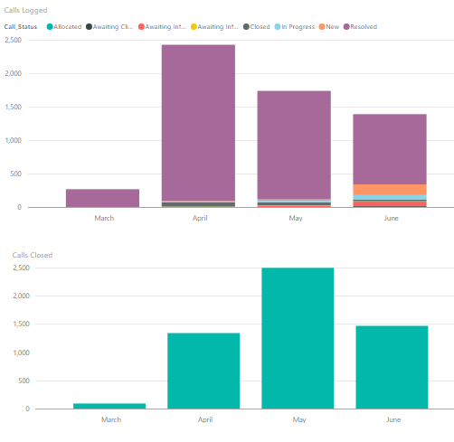

- The chart overleaf shows the number of calls logged per day (green) and the number resolved (black). It has been very positive that over 80% of calls have been logged using the new self-service portal allowing the ICT team to concentrate on resolving issues.
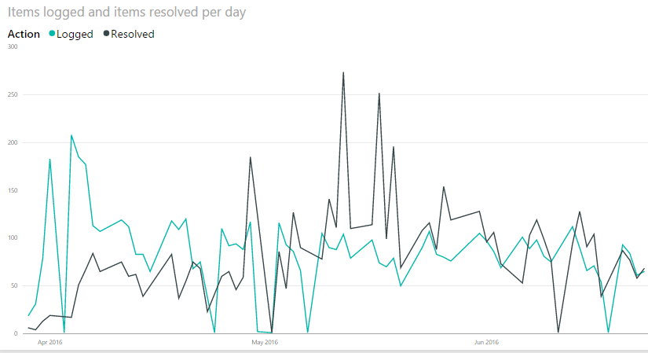

- The major issues we have faced and a current position statement is provided below.

MS Exchange / Public Folders - Resolved.
- Not all of the data for group emails (63GB) was originally transferred as part of email migration to Exchange 2010. This data was recovered in the first week after transition, but caused a loss of service for the mail accounts for 3 days. The problem was exacerbated by accidental deletion of the content which had to be recovered leading to unavailability for another working day. This included key public facing email accounts to allow the public to send emails to business services (e.g. Building control, Scrutiny). The accounts were all enabled to allow ongoing access to email, and there was a resource allocated to complete the task by 29th April.

File Store - Resolved.
- Many users were reporting missing data from the day prior to migration. The majority of this data was recovered almost immediately. However, residual issues meant the m:drive and archive server were both recovered by the County and made available for users week commencing 13th and 20th June respectively, resulting in all outstanding requests for missing files and data have now been fulfilled.

Permissions - Resolved.
- Due to increased security arrangements on the SCC infrastructure, users experienced network permission issues preventing access to certain files and folders. Two new file servers have been built by SCC and our content migrated over to them so we can retire the original servers which had been the source of many of the permission issues.

Software Centre (SCCM)
- These calls relate to accessing the client software, as it does not load properly from the software centre. There is a work around in place, and we have had a specialist resource on site to explore the long term fix.
- New laptops are being deployed using the automated tools. The process can be refined further as we get feedback from the initial users. We also have a stock of tablet devices and are working on deploying Windows 10 so users have access to the touch screen capability.

- We have identified some issues with automated updates of windows patches and anti-virus files. There is a manual work around and we are implementing fixes so it will return to an automated process.

Information@Work -Resolved.
- This is a document management system used by Revenues, Benefits and Housing. Post migration performance was degraded and there were several areas not functioning, notably scanning of new documents. The missing data has now been recovered and the indexing problems resolved.

ICT for Members
- Members were contacted individually in April to confirm what devices and access methods they used, in order to identify any issues and common themes, and ensure that a systematic resolution could be put in place. This identified that access via Council BT Onephones was good, and training was offered to new and existing members where required. There were initial issues with members who used their own devices to access our systems, which have now been resolved. Members’ room access is also fine.

- iPads have been the most significant area of concern for members, and more specifically the operation of Airwatch. It should be noted iPads issued to Officers appear to be working satisfactorily. To resolve this situation we have worked closely with BT and Airwatch, we have: created a test environment to replicate issues; conducted a server upgrade to eradicate any known issues; replaced iPads where applicable; deployed the native iPad mail client to 19 councillors (currently this is being offered as and when they are having issues with AirWatch) and we are testing the iPad Outlook client as a third option.

Resources
- Performance is being monitored and reported daily at both a summary and individual staffing level to ensure colleagues understand and are achieving targets as well as dealing with priority issues. Weekly one to one meetings with staff to manage performance are also in place.

- Additional resources have been sourced to support the existing core ICT teams, this includes:
- Retaining the existing Transition technical resources until the middle of July
- Bringing in suppliers and specialist technical resources to tackle outstanding problems
- Additional senior technical analysts and service desk analysts recruited to address the remaining issues and work through the remaining calls.

The Way Forward

Communications
- The key managers in Business Improvement continue to have daily briefings within the team to ensure we are focused and co-ordinated in our approach, prioritising issues and closing them down as quickly as possible.

- We are updating colleagues with the current ICT position using all staff emails and refreshing the intranet. We have been liaising with each service area as required, ensuring we are agreeing with Services what their priorities are for ICT resolution.

- A weekly progress report addressing the outstanding issues is given to the Executive Director for OD & Corporate Services and the Chief Executive.

Development Plans
- The ICT Team are working up their own development plans to embed the systems and processes that have just been implemented. In addition SOCITM have been appointed to undertake a critical friend review of the functions and skills required to deliver our service effectively.

